Project Design Phase-II
Technology Stack (Architecture & Stack)

Date | 31 January 3035
Team ID | LTVIP2026TMIDS86052
Project Name | Smart Sorting: Transfer learning for identifying rotten fruits and vegetables
Maximum Marks | 4 Marks

Technical Architecture:
The Deliverable shall include the architectural diagram as below and the information as per the table1 & table 2
Example: Smart Sorting: Transfer learning for identifying rotten fruits and vegetables
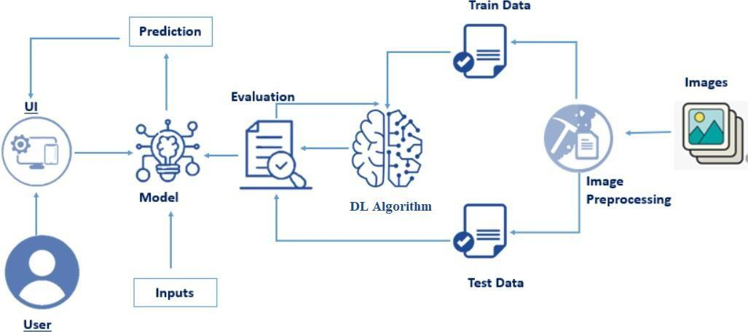

Table-1 : Components & Technologies:
S.No | Component | Description | Technology
 | User Interface | Web interface for uploading fruit/vegetable images and displaying results |  | HTML, CSS, JavaScript
 | Application Logic-1 | Handles image upload and preprocessing (resizing, normalization) | Python (Flask)
 | Application Logic-2 | Model integration and prediction logic | TensorFlow / Keras
 | Application Logic-3 | Displays prediction results (Fresh / Rotten) | Python Backend Logic
 | Database | Stores prediction results and user history | MY SQL
 | Cloud Database | Cloud-based data storage | Firebase / MongoDB Atlas
 | File Storage | Stores uploaded images | Local File System / Cloud Storage
 | External API-1 | Fetch fruit/vegetable information | Open Food Facts API
 | Machine Learning Model | Image classification for Fresh vs Rotten detection | Transfer Learning (ResNet50 / MobileNetV2 / VGG16)
 | Infrastructure (Server / Cloud) | Deployment of application | Local Server / AWS / Google Cloud

Table-2: Application Characteristics:
S.No | Characteristics | Description | Technology
 | Open-Source Frameworks | Frameworks used for ML model and web app | TensorFlow, Keras, Flask
 | Security Implementations | Secure image upload and data protection | HTTPS, Password Hashing (SHA-256)
 | Scalable Architecture | 3-tier architecture (UI, Logic, Database) | Cloud Deployment
 | Availability | System accessible online 24/7 | AWS / Google Cloud
 | Performance | Optimized model for faster prediction | Transfer Learning, Image Preprocessing

